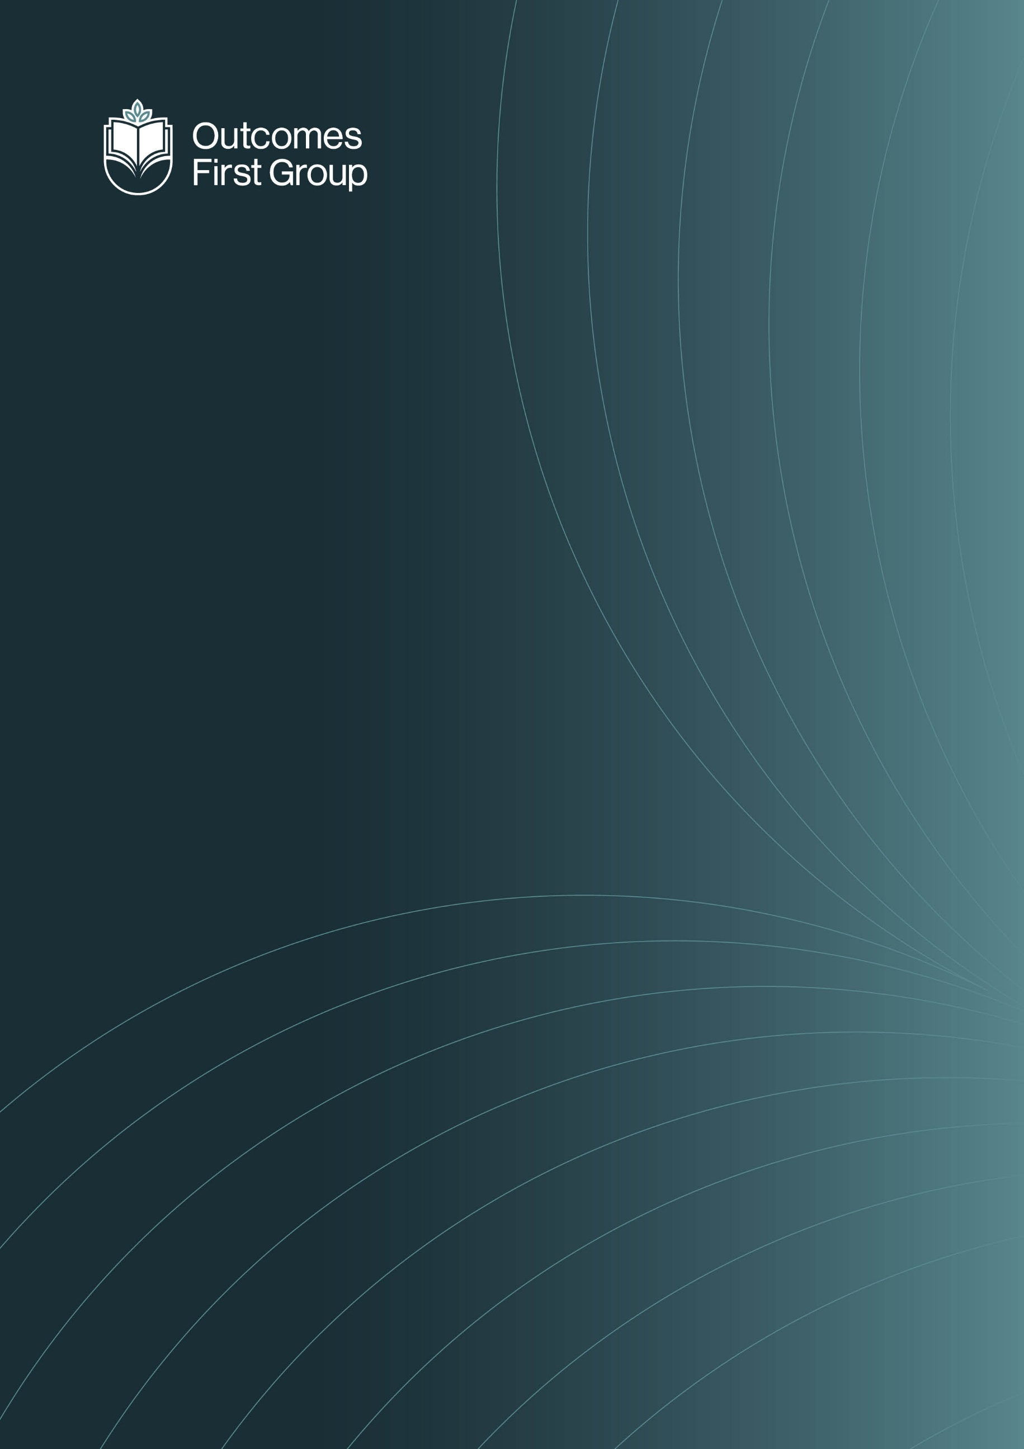
PSHE Policy

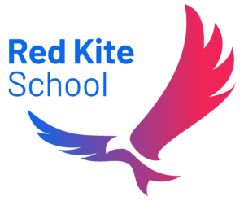

PSHE POLICY

Contents
INTRODUCTION AND CONTEXT 2
PSHE 3
STATUTORY REQUIREMENTS 3
DEFINITIONS 4
CURRICULUM DELIVERY 4
Relationships Education 5
Sex Education 5
Health Education 6
CURRICULUM CONTENT 7
SPECIAL EDUCATIONAL NEEDS AND/OR DISABILTIES 7
EQUALITY 7
ASSESSMENT 8
Staff 8
PSHE Subject Lead 9
Health and Therapy Team 9
Pupils 9
PARENTS RIGHT TO WITHDRAW 9
POLICY DEVELOPMENT 11
POLICY MONITORING AND REVIEW 11
APPENDIX 1: HOW THE PSHE EDUCATION PLANNING FRAMEWORK FOR PUPILS WITH SEND RELATES TO THE PSHE ASSOCIATION PROGRAMME OF STUDY 12

INTRODUCTION AND CONTEXT

Red Kite School is a school for young people aged 11-18 years with a diagnosis of SEMH needs, communication and interaction and associated challenging behaviour.
The aim of the education provided at Red Kite School is to develop social interaction and communication skills to allow young people to express their needs and to stimulate curiosity in the world around them.. All of our children and young people have significant barriers to learning due to their health conditions. All of our young people are extremely vulnerable and many have experienced disruption to formal education.
As a school for children with SEMH needs, our aim is that pupils make the maximum progress possible in the areas of difficulty typically associated with that diagnosis, including their social communication, emotional regulation, and sensory processing. Our curriculum also aims to ensure pupils can both sustain and generalise the skills they acquire, over time, and across different contexts and circumstances. Above all, our aim as a school is to ensure our pupils leave us with the highest possible levels of independence and autonomy, whether that be through the acquisition of practical and academic skills, regulation of their own sensory and emotional needs, or effective articulation of their own choices and pursuit of their own interests and life goals. Our PSHE curriculum is flexible, adaptable and robust enough to meet the ever-changing demands of the modern world and best prepare our young people for a life within it.

PSHE
At Red Kite School, we teach Personal, Social, Health, Economic (PSHE) education across the weekly learning pupils undertake. This underpins our students’ development as this best supports their learning capacity best. We follow the PSHE Education Planning Framework written by the PSHE Association (see Appendix 1 & Appendix 2) to ensure our curriculum integrates, but is not limited to, the new statutory content. Our Personal, Social, Health, Economic education also includes Relationships, Health and Sex Education (RHSE).
Our broad and balanced PSHE curriculum helps our young people to become informed, thoughtful and responsible citizens who are aware of British Values, and wherever possible, their duties and rights. It encourages pupils to make a positive contribution to the life of their school, neighbourhood, communities, and the wider world. It encourages respect for different nations, religious and ethnic identities. It also helps students to develop an understanding of the world of work, at a level that matches their age and complex SEND.

STATUTORY REQUIREMENTS
“The Relationships Education, Relationships and Sex Education and Health Education (England)
Regulations 2019, made under sections 34 and 35 of the Children and Social Work Act 2017, make
Relationships Education compulsory for all pupils receiving primary education…They also make
Health Education compulsory in all schools except independent schools. Personal, Social, Health and Economic Education (PSHE) continues to be compulsory in independent schools.”
DfE Guidance p.8
In all Key Stages we teach Relationships education with sex education being taught discretely, in line with cognition and receptive understanding (this is determined in consultation with the Clinical Team, SLT and parents and carers), with all pupils being taught Health Education, thus following the statutory guidance as set out by the Department of Education and the Independent School Standards.
In addition, at Red Kite School:
- Teaching reflects the law and teaches about applicable laws so that pupils are clear on rights and responsibilities
- Teaching is sensitive, inclusive, and age-appropriate
- Teaching is inclusive to meet the needs of all pupils so that they are able to understand the importance of quality and respect
- We work closely with parents and are respectful of pupils’ and parents’ backgrounds and beliefs
- We communicate the right to request withdrawal from some or all of the sex education
- We will take into account the age and religious background of all pupils
- We make sure that RSHE is accessible to all pupils, including those with SEND
- We teach about LGBTQIA+ content at integrated and timely point
- The staff team and wider community model positive relationships

Red Kite School complies with the Equality Act 2010:
- We will not treat pupils with protected characteristics (age, sex, race, disability, religion or belief, gender reassignment, pregnancy or maternity, marriage or civil partnership, or sexual orientation) less favourably.
- We will make reasonable adjustments and take positive action to alleviate disadvantage, being mindful of the SEND Code of Practice.
- We will regularly review our Accessibility Plan to ensure we are taking positive action towards inclusivity.
Parental and Carer Consultation
At Red Kite School, we recognise the importance of working closely with parents and carers to ensure that our PSHE curriculum meets the diverse needs of our pupils. We are committed to transparency and collaboration and will consult with parents and carers on any significant changes or amendments to the PSHE policy. This consultation process allows families to share their views, ask questions, and contribute to the development and delivery of a curriculum that reflects the needs and values of our school community. We believe that strong partnerships with families are essential to the success and wellbeing of our pupils.

DEFINITIONS
Relationships and Sex Education (RSE) is about the emotional, social and cultural development of pupils, and involves learning about relationships, sexual health, sexuality, healthy lifestyles, diversity and personal identity. RSE involves a combination of sharing information and exploring issues and values. RSE is not about the promotion of sexual activity.
Health Education is focused on teaching pupils how to make good decisions about their own physical health and mental wellbeing. It involves learning about what is normal and what is an issue and teaches pupils how and who to seek support when needed.

CURRICULUM DELIVERY
“Schools are free to determine how to deliver the content set out in the DfE guidance 2019 in the context of a broad and balanced curriculum. Effective teaching in these subjects will ensure that core knowledge is broken down into units of manageable size and communicated clearly to pupils, in a carefully sequenced way, within a planned programme of lessons.”
DfE Guidance p.8
At Red Kite School, we include the statutory Relationships and Health Education and Sex Education within our whole-school Personal, Social, Health, Economic (PSHE) education curriculum. Biological aspects of Relationships and Sex Education are also taught at a time that reflects the pupils SEND needs.
At Red Kite School we use a holistic, person-centred approach to the development of our young people to ensure they achieve the best possible outcomes. Although we follow a framework that is organised into key stages, our PSHE curriculum is flexible and key stages are followed depending on the individual needs and main areas of development within that class, as opposed to their age group.
Teachers take into account the needs and feelings of pupils’ and deliver the content of the PSHE curriculum in a developmental and age-appropriate way, suited to individual needs. Each class also has class assemblies, and has praise and reward systems in place, that are personalised for their pupils.
PRIMARY CURRICULUM CONTENT

Relationships Education
The Relationships education focuses on teaching the fundamental building blocks and characteristics of positive relationships including:
- Families and close positive relationships
- Friendships
- Managing hurtful behaviour and bullying
- Safe relationships
- Respecting self and others

Sex Education
The DfE Guidance 2019 (p.23) recommends that all schools ‘have a sex education programme tailored to the age and the physical and emotional maturity of the pupils’. (p.23)
Schools are to determine the content of sex education at primary school. Sex education ‘should ensure that both boys and girls are prepared for the changes that adolescence brings and – drawing on knowledge of the human life cycle set out in the national curriculum for science - how a baby is conceived and born’.
We define sex education as understanding human reproduction. We believe that all children at our school should have access to a sex education programme to enable them to:
- Be safe
- Be provided with the correct scientific terminology and information and taught how to use it in the right context
- Make responsible, informed and healthy choices about their lives now and in the future
- Be respectful of themselves and others to enable them to move confidently through childhood, adolescence into adulthood
- Have the understanding to develop and maintain positive and healthy relationships

HEALTH EDUCATION
The Health Education focuses on the following key areas:
- Mental wellbeing
- Internet safety and harms
- Physical health and fitness
- Healthy eating
- Drugs, alcohol and tobacco
- Health and prevention
- Basic first aid
- Changing adolescent body
Teaching children about puberty is now a statutory requirement which sits with the Health Education part of the DfE guidance within the ‘Changing adolescent body’ strand.

Sex Education

CURRICULUM CONTENT
The Sex Education focuses on giving young people the information they need to help them develop healthy, nurturing relationships of all kinds including:
- Families
- Respectful relationships, including friendships
- Online and media
- Being safe
- Intimate and sexual relationships, including sexual health
These areas of learning are taught within the context of family life taking care to ensure that there is no stigmatisation of children based on their home circumstances (families can include single parent families, LGBTQIA+ parents, families headed by grandparents, adoptive parents, foster parents/carers amongst other structures) along with reflecting sensitively that some children may have a different structure of support around them (for example: looked after children or young carers).
CAREERS EDUCATION:
Red Kite School provides careers education and guidance programme for its pupils in all years. Careers will be delivered within our PSHE programme, as well as throughout other lessons, with curriculum visits highlighting the routes into the workplace in a variety of sectors. We will follow the Gatsby Benchmarks.
The primary learning outcomes of this programme are:
Self-development: Pupils should learn how to understand themselves and develop their capabilities.
Career exploration: Pupils should learn how to investigate career and opportunities.
Career management: Pupils should learn how to implement their career plans.
Pupils in all years will have positive careers input by school staff, as well as trained external careers advisers from Suffolk.
Please see the Careers Policy for greater detail on careers.

British Values
British values are promoted in so much of what we do, not least during our school assemblies, Humanities and in PSHE. Modern British values are integral to our school vision and ethos and underpin our daily school lives. As well as actively promoting British values in school, the opposite also applies: we would actively challenge pupils, staff or professionals expressing opinions contrary to fundamental British values, including ‘extremist’ views.
Please refer to the British Values Policy to read more about the British Values education that we follow.

SPECIAL EDUCATIONAL NEEDS AND/OR DISABILTIES
All pupils at Red Kite School have additional learning needs and all have an Education Health Care Plan (EHCP). Red Kite School is committed to providing the environment and opportunities to enable all children and young people with special educational needs to be included, fully, in all aspects of Red Kite School life. We have adapted our curriculum to ensure each young person has access to a broad and balanced curriculum that is meaningful, appropriate and individually challenging in relation to their complex SEND.
Classroom resources are differentiated as appropriate to address the learning needs of each pupil for them to have full access to the contents of the PSHE and RHSE curriculum. All teaching and learning opportunities are underpinned with specific objectives, based on individual needs. EHCP outcomes are integrated into the school day and embedded throughout our curriculum. In addition, our health and therapy team work closely together and in collaboration with school, parents/carers and other professionals to provide a holistic approach.

EQUALITY
The DfE Guidance 2019 (p. 15) states, “Schools should ensure that the needs of all pupils are appropriately met, and that all pupils understand the importance of equality and respect.
Schools must ensure they comply with the relevant provisions of the Equality Act 2010 under which sexual orientation and gender reassignment are amongst the protected characteristics…”
LGBTQIA+ content is integrated fully into our curriculum. It is not specifically taught as stand-alone lessons within units. All young people will be taught LGBTQIA+ content in an age-appropriate manner at a timely point in the curriculum, and at a level that matches the pupils complex SEND.
At Wetheringsett Manor School we promote respect for all and value every individual child. However, we also respect the rights of our children, families and our staff to hold beliefs, religious or otherwise.
Should any content within our curriculum cause parents or carers any concern then we would invite them in to discuss these concerns with the school.
For information on what is taught, please refer to Appendix 1 and Appendix 2.

ASSESSMENT
Assessment is integral to teaching and learning in PSHE and is carried out in accordance with the whole-school policy. We use the PSHE Education Assessment Framework for Pupils with SEND to help track our young people’s progress in PSHE and identify areas of development. Our assessment is ongoing and is continually captured throughout the school day when our pupils are seen applying their skills and knowledge in real-life situations or to different subjects using Evidence for Learning.
The style of assessment used is non-threatening and promotes the young people’s self-esteem. There are clearly defined links between objectives and assessment. The criteria by which the work is to be judged are shared and accessible by the young people, where appropriate. Assessment is continuous and the outcomes of the process are used to inform subsequent teaching. Young people receive regular feedback from their teachers concerning their progress and achievement and this is communicated to parents, carers and associated professionals in termly subject reports and in the statutory annual review documentation.
ROLES AND RESPONSIBILITIES
The Headteacher
The Headteacher is responsible for ensuring that RSE is taught consistently across the school, and for managing requests to withdraw pupils from the non-statutory components of RHSE.

Staff
Staff are responsible for:
- Delivering RHSE in a sensitive way
- Modelling positive attitudes to RSE
- Monitoring progress
- Responding to the needs of individual pupils
- Responding appropriately to pupils whose parents wish them to be withdrawn from the non-statutory components of RSE
- Communicating with parents when Sex Education is being delivered
Teachers are empowered to deliver PSHE discretely, across the academic year to ensure consistency, but PSHE is not always taught to classes by their teacher.
Staff do not have the right to opt out of teaching RSE. Staff who have concerns about teaching RSE are encouraged to discuss this with the Headteacher and appropriate training will be arranged.

PSHE Teacher
The PSHE Teacher is responsible for ensuring pupils are receiving high quality PSHE lessons that are accessible and tailored to individual needs. They will ensure the framework informs planning, teaching and assessment. They will share knowledge, good practice and keep staff up to date with the current statutory guidance.

Health and Therapy Team
Our Clinical team provides information to support a holistic approach to the teaching and learning of PSHE. They provide advice, guidance and resources to support staff in ensuring all young people can access our PSHE curriculum. They may also provide 1:1 support to deliver specific interventions based on individual needs.

Pupils
Pupils are expected to engage fully in PSHE and, when discussing issues related to PSHE, treat others with respect and sensitivity. Sometimes, where we are aware of a child’s previous trauma, we will work with their complex SEND to find the best time and place to deliver PSHE content.

PARENTS RIGHT TO WITHDRAW
“Parents have the right to request that their child be withdrawn from some or all of sex education delivered as part of statutory Relationships and Sex Education”
DfEGuidance p.17
All staff at Red Kite School strongly believe that all children should have access to our sex education programme as outlined above. If a parent/carer wishes to withdraw their child from Sex Education lessons, then they must inform the school in writing prior to the lesson taking place in order that alternative arrangements can be made for the child’s education.
Parents do not have the right to withdraw their children from relationships education. Parents have the right to withdraw their children from the non-statutory components of sex education within RSE. Requests for withdrawal should be put in writing and addressed to the Headteacher. Alternative work will be given to pupils who are withdrawn from sex education.
There are separate rules on withdrawing a child from Sex Education. Sex education is separate from the Relationships and Health curriculum and parents can withdraw children from some or all of the lessons on Sex Education. The head teacher must grant a parent’s request to withdraw a child beforehand, and it’s useful to have good conversations with parents so that they understand fully what their child will be taught.
Before making a request, parents should:
- Ask the school about what will be taught in Sex Education, and when.
- Remember that the science curriculum in all schools includes content on human development, which includes human reproduction.
- Remember there is no right for a parent to withdraw their child from the science curriculum or from the relationships aspect of the RHSE curriculum.

POLICY DEVELOPMENT
This policy will be reviewed annually
- Review – a member of staff or working group will look at all relevant information including relevant national and local guidance
- Staff consultation – all school staff will be given the opportunity to look at the policy and make recommendations
- Parent/stakeholder consultation – we will write to parents to outline our plans for what is going to be taught and how. Parents and stakeholder views will be considered. This policy will be shared with parents. Parents will be invited to share their views.
- Pupil consultation – we will endeavour to develop pupil voice to know exactly pupils want from their PSHE and RSE lessons
- Ratification – once amendments were made, the policy will be shared with governors and ratified

POLICY MONITORING AND REVIEW
The PSHE lead along with the senior leadership team monitor this policy on an annual basis.

APPENDIX 1: HOW THE PSHE EDUCATION PLANNING FRAMEWORK FOR PUPILS WITH SEND RELATED TO THE PSHE ASSOCIATION PROGRAMME OF STUDY:
The PSHE education planning framework for pupils with Special Educational Needs and Disabilities (SEND) is closely aligned with the PSHE Association Programme of Study. It has been designed to ensure that all pupils, regardless of need, are able to access a high-quality, inclusive PSHE curriculum that supports their personal development, wellbeing, and safety.
The PSHE Association Programme of Study provides a comprehensive structure of learning opportunities across three core themes: Health and Wellbeing, Relationships, and Living in the Wider World. The SEND planning framework complements this by adapting these themes to meet the diverse needs of pupils with SEND, ensuring content is accessible, appropriately sequenced, and delivered in a way that reflects pupils’ developmental stages rather than solely their chronological age.
In practice, this means that while the overarching learning intentions remain consistent with the Programme of Study, the SEND framework may:
- Break down learning into smaller, more manageable steps.
- Revisit key concepts more frequently to support understanding and retention.
- Use a greater emphasis on practical, experiential, and visual learning approaches.
- Prioritise essential knowledge and skills, particularly those relating to communication, independence, personal safety, and emotional regulation.
The framework also places strong emphasis on teaching that is personalised and responsive. This includes adapting language, using concrete examples, and providing additional support where needed, to ensure that all pupils can engage meaningfully with the content.
Furthermore, the SEND planning framework supports the statutory requirements of Relationships Education, Relationships and Sex Education (RSE), and Health Education by ensuring that pupils with SEND are taught the same core content as their peers, with appropriate adaptations. This is particularly important in areas such as personal safety, consent, relationships, and managing risk, where pupils with SEND may be more vulnerable and therefore require clear, explicit teaching.
Assessment within the SEND framework is also aligned with the PSHE Association guidance, focusing on pupils’ progress in knowledge, understanding, and skills, rather than solely on written outcomes. Staff use ongoing, formative assessment to tailor learning and ensure that pupils are making meaningful progress.
In summary, the PSHE education planning framework for pupils with SEND does not replace the PSHE Association Programme of Study but works alongside it. It ensures that the curriculum is inclusive, equitable, and accessible, enabling all pupils to develop the knowledge, skills, and attributes they need to lead safe, healthy, and fulfilling lives.

