Careers Education,
Information, Advice and Guidance Policy

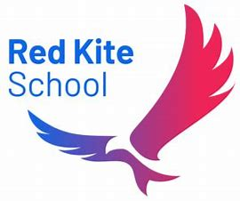

Updated September 2025

Document History
Version | Comments/amendments | Name | Date
1 | New policy document | Lucy Metcalfe | 29/09/2025

Contents
1.0 INTRODUCTION 3
2.0 COMMITMENT 3
3.0 AIM 3
3.1 What will our students experience throughout their career curriculum? 3
3.2 Why do we want this? 4
3.3 How will we deliver this? 4
3.4 What will success look like for our students? 4
4.0 STUDENT ENTITLEMENT 4
4.1 Equality and Diversity 4
5.0 CURRICULUM DELIVERY 5
5.1 Pre-secondary level 5
5.2 Year 7 5
5.3 Year 8 5
5.4 Year 9 5
5.5 Year 10 5
5.6 Year 11 5
6.0 WORK EXPERIENCE 5
6.1 The value of work experience 5
6.2 Aim of Work Experience: 6
6.3 Stages of Work Experience Program 7
6.4 Supporting Young People on Work Experience 7
7.0 PARENTS AND CARERS 8
8.0 STAFFING 8
9.0 MONITORING, REVIEWING AND EVALUATION 8
APPENDIX 1 – DEFINITIONS AND STATEMENT OF ENTITLEMENT 9

1.0 INTRODUCTION

The Careers Lead for Red Kite School is Lucy Metcalfe.

Careers education and guidance programs make a major contribution to preparing young people for the opportunities, responsibilities, and experiences of life. A planned progressive program of activities supports them in choosing pathways that suit their interests and abilities and help them to follow a career path and sustain employability throughout their working lives.

2.0 COMMITMENT

Our school is committed to providing our students with a program of careers education, information, advice and guidance (IAG) for all students in years 7–11 which is impartial and effective. Students working pre-secondary level receive age-appropriate carers education through their main curriculum offer. We aim to support the aspirations of our students and ensure that they gain the understanding, skills and experience to make progress and succeed in learning and work.

Red Kite school endeavours to follow the Careers guidance and access for education and training providers (DfE, 2018 & May 2025 updates) and other relevant guidance from QCA and Ofsted as it appears.

The school has a member of staff dedicated to careers education and IAG. We provide students with the knowledge, information and skills to make informed choices about suitable courses at school, college and other providers. The service enables students to receive accurate information, advice and guidance about the options open to them and the progression routes to which those options lead.

3.0 AIM

We want our students to experience a careers curriculum that establishes a growing knowledge and awareness of the world of work and what they, as young people, can aim for as they prepare for adulthood and Post 16 transition. This includes delivering a breadth of opportunities and experiences that our students can start to build their own future pathways on. As we aim to do this, we are also fully aware of the impact of the inherent difficulties our students have due to the nature of their needs and diagnosis and look to how we can start to overcome these barriers, working alongside them.

3.1 What will our students experience throughout their career curriculum?
- Access to careers learning from Year 7 onwards - learning that is linked through their curriculum provision and explicitly delivered sessions.
- A careers curriculum that has contributions and feedback from them, their families, school staff and external employers
- Engagement with many different employers throughout Year 7 to Year 11 in variety of formats such as assemblies, visits, talks, project work, careers events
- Unbiased careers advice and support from a career's advisor
- Working with them and their families as they prepare for their future and for life after education.
- Staff who are committed to and passionate about helping them develop as they make key decisions and prepare for their future pathways

3.2 Why do we want this?
- We want our students to know their skills and strengths; know what they are good at and what they find hard.
- We want our students to work towards independent living and working.
- We want them to have hope and optimism, adaptability and resilience.
- We want our students to have access to, and engagement in, decent work in all its forms (personal, gift and paid)
- We want our students to learn and make progress so they can thrive and experience success in their future pathways.
- We want our students to pursue and value their own wellbeing and happiness

3.3 How will we deliver this?
- Students will have access to a careers curriculum from Year 7 onward and this will be routinely monitored and evaluated to ensure it is fit for purpose.
- Students will be presented with opportunities to meet and talk with previous students to find out about their experiences and aspirations.
- Close working relationship with our Careers Advisor to support mentoring students in KS4.
- Experiences of different workplaces and environments
- Meaningful encounters with the world of work Careers fairs and skills workshops

3.4 What will success look like for our students?

- Students will have a successful transition on from Year 11 into Post 16
- Students will have had experience of a wide range of opportunities, interests and options so they are best placed to make informed decisions about their future choices.
- Students will develop the skills needed for them to be employable, whether that is voluntarily or paid.
- Students will know the value of having work and commitments in their lives.
- Students will know that they have a valued and important part to play in the world in which they live, and they can and are motivated to contribute to society in a way which best suits their interests and skills.
- Students will know about and make use of the range of support and advice that is available to them in order to support their choices and decision making.

4.0 STUDENT ENTITLEMENT

Careers Education and guidance (CEG) is an important component of the 11-16 Curriculum, we fully support the statutory requirement for a program of careers education in Years 7–13. Students have access to a group careers program. This gives them the opportunity to explore the different careers, qualifications and learning routes. Students also have direct careers meetings and the attendance of or CEG lead at PEP’s, LACS and EHC reviews.

4.1 Equality and Diversity

Careers education is provided to all students and provision is made to allow all students to access the curriculum. Students are encouraged to follow career paths that suit their interests, skills and strengths with the absence of stereotypes. All students are provided with the same opportunities and diversity is celebrated. Due to us having our own on-site careers lead, we provide excellent knowledge of our students needs and can tailor our approach in line with EHCP needs.

5.0 CURRICULUM DELIVERY

5.1 Pre-Secondary Level
Students working pre-secondary level encounter experiences of careers and job roles through the citizenship element of the Myself, Relationships and Staying Safe Curriculum.

5.2 Year 7
The focus is about introducing careers and thinking about the vast number of careers/jobs available. How a business runs, qualities and skills that employers look for as well as and rights and responsibilities in the world of work.

5.3 Year 8
The focus is linking our plans and dreams to reality. Identifying a support network when considering careers and recognising health and safety risks.

5.4 Year 9
The focus is self-assessment, considering own strengths, stereotyping and discrimination as well as career paths and options post 14.

5.5 Year 10
The focus is work experience including preparation, implementation and evaluation. Not all students undertake work experience outside school due to their vulnerability and increased risk. Many will undertake work experience within the school, and this can be part of project work in vocational subjects. All work experience placements are assessed with regards to suitability and health and safety.

5.6 Year 11
The focus is post 16 options and the application process. There will be visits to other educational/training providers, places of work, career fairs and also job centres and business enterprise specialists.

In addition to the year group specific Careers programme we organise visitor to the school to talk to the students about their career choices and journeys to offer a wide yet informal source of information and to provide opportunities for discussion and questioning.

6.0 WORK EXPERIENCE

6.1 The value of work experience

• Social Skills

Students will be able to experience working as part of a group and learning to work with new people and adults in a work situation.

• Personal Development

Work experience will help students understand the different roles and respond to different routines.

They can practice decision-making skills, be responsible for their own actions and the effect these actions have on others.

Students will develop communication skills in different contexts.

Work experience can play an important role in the development of student’s self-image and maturity.

Work experience should enable students to experience the success and frustrations of seeing a project through to completion.

• Knowledge and Understanding

Students will be aware of the disciplines of work and the differences that exist between school and work.

Students will see the effect of new technology and gain knowledge of Health and Safety issues.

6.2 Aim of Work Experience:

- To support and encourage an integrated work experience program.
- To enable the development and learning of students
- To provide students with records/documents to provide evidence of their experience.
- To ensure all placements are safe and secure.
- To provide students with direct experience of the world of work
- To give students the experience of relationships, routines and processes that are part of a working environment.
- To develop work related skills
- To contribute towards approved vocational and academic qualifications where necessary.
- To prepare students for adult and working life
- To encourage students to widen their horizons by viewing work experience as an opportunity to sample non-traditional areas of work.
- To prepare students by discussing equal opportunities
- To make clear the roles and responsibilities of all involved in work experience.
- Work experience can provide an excellent opportunity for students to develop an understanding of what an employer will expect of them and so enhance their employability.
- Various patterns and length of work experience placements need to be flexible to ensure that the learning needs of our students are met.
- The work will be appropriate to the student’s capabilities.
- There will be an adequate level of supervision provided throughout the placement.
- Placements are assessed for risks and insurance checked.

6.3 Stages of Work Experience Program

- Student to meet with Careers Teacher to discuss and identify a student’s choice of placement.
- Meeting with school staff and care staff. Risk assessment carried out.
- Careers Teacher to make contact with suitable establishments, insurance checks and risk assessment.
- Attendance – Students may benefit from a block week/week’s attendance. Some students may benefit from several one-day placements over a period of time to build their confidence and to prepare them for an extended period. For others the most appropriate way to meet their needs may be a pattern of one day a week over several weeks.
- Diary/logbook to be kept by the student, showing what tasks are carried out each visit.
- Career Teacher to visit a student in placement.
- Evaluation – we need to evaluate the placement. We should discuss with the student what they did, identify skills they have improved and acknowledge what they have learned.
- Follow up – letter of thank you to be sent to employers.
- Evaluation – evaluate the success of the placement.

6.4 Supporting Young People on Work Experience

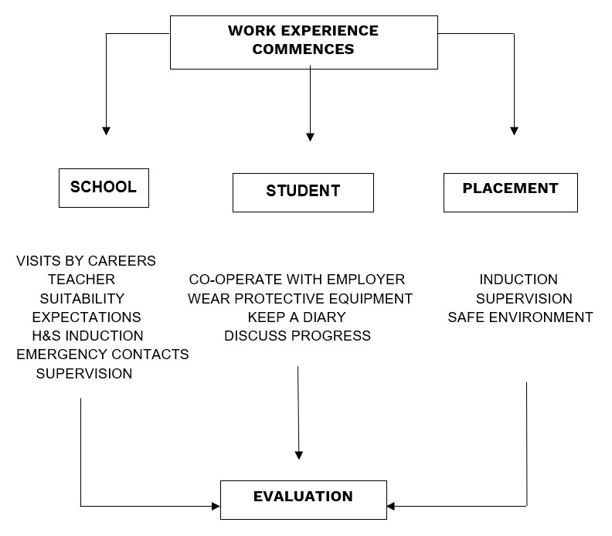

7.0 PARENTS AND CARERS

Parental involvement is encouraged at all stages. Online resources have been specifically chosen to help parents become more involved. Parents / carers are kept up to date with careers related information through letters and newsletters relating to local events, and the CEG of each student’s academic report. Parents / carers are welcome at careers interviews and where necessary are invited. Regular updates are also given at reviews (EHCP, PEP, and LAC)

8.0 STAFFING

All staff contribute to CEG through their roles as tutors and subject teachers.

The Careers program is planned, monitored and evaluated by the Careers Teacher.

The careers teacher will liaise and consult with the Group Careers Advisor to ensure that specialist career guidance is available when required.

9.0 MONITORING, REVIEWING AND EVALUATION

Careers Education is monitored and evaluated annually via the Deputy and Headteacher. Careers Guidance is monitored and evaluated annually through discussion with key staff and students and appropriate observation of activities by the SLT.

When reviewing the program, the School Development Plan (SDP) is used to ensure that the Careers provision is fully supporting whole school aims.

APPENDIX 1 – DEFINITIONS AND STATEMENT OF ENTITLEMENT

Statement of entitlement

As a student of Red Kite School, you are entitled to receive a program of careers education, advice, information and guidance.

Your Careers Education and Guidance program will help you to:
- Understand yourself, your interests, likes and dislikes, what you are good at and how this affects the choices you make.
- Find out about different courses, what qualifications you might need and what opportunities there might be.
- Develop the skills you may need for working life.
- Make realistic, but ambitious, choices about courses and jobs.
- Develop a plan of action for the future.
- Understand the different routes after Year 11 including training, further and higher education and jobs.
- Be able to make effective applications for jobs, training and further and higher education.
- Develop your interview skills.
- Improve your confidence.

You will receive:
- Careers lessons
- Guided tutor time
- Access to the career’s interviews
- Interviews with the groups qualified advisors.
- Work experience where appropriate • Other subject lessons linked to careers.

You can expect to be:
- Treated equally with others.
- Given careers information and advice that is up to date and impartial.
- Treated with respect by visitors to the school who are part of the careers program.

