Local Offer
Bucks Skills Hub

Post-16 SEND opportunities
Work Experience & Internships | Opportunities | Buckinghamshire Skills Hub
Work Experience | Opportunities | Buckinghamshire Skills Hub

Local Colleges

Oxford Road, Aylesbury, Buckinghamshire,
HP21 8PB
Aylesbury UTC - University Technical College, Aylesbury


Aylesbury Campus
Oxford Road
Aylesbury
Buckinghamshire
HP21 8PD
01296 588 588

High Wycombe Campus | Buckinghamshire New University
Queen Alexandra Road, High Wycombe, Buckinghamshire, HP11 2JZ.

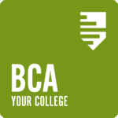
BCA
BCA, Hall Place, Burchetts Green,
Maidenhead, Berkshire, SL6 6QR
01753 793000
enquiries@bca.ac.uk

